Government Engineering College, Bhuj
Assignment-2 (Engineering Physics)
Ch-3, 4, 5, 6, 7, 9, 10

Ch-5 LASER

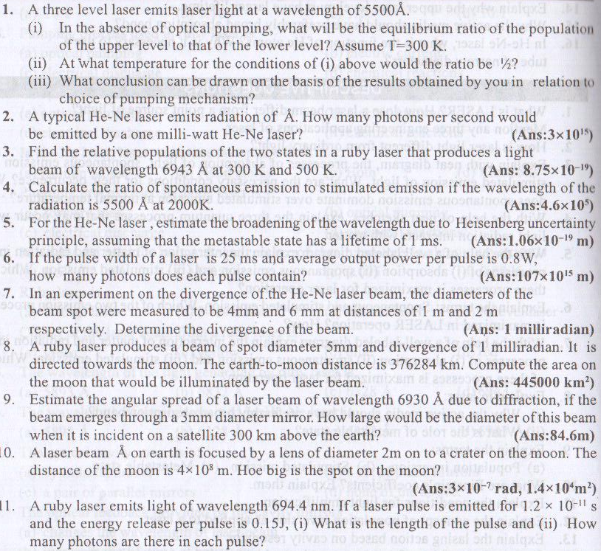

Ch-6 FIBER OPTICS
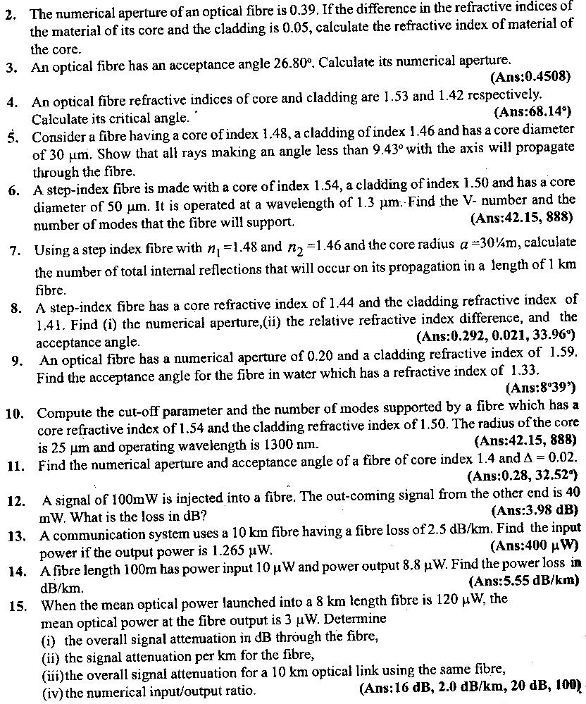

Ch-7 CONDUCTING MATERIAL
