Government Engineering College, Bhuj
Assignment-2 (Engineering Physics)
Ch-3, 4, 5, 6, 7, 9, 10

Ch-3 Crystal Physics
- Explain- Unit Cell
- Write short note on Crystal Systems.
- State three laws of crystallography.
- What is Hauy’s law? Explain shortly.
- Explain Miller Indices with proper example.
- Define: Co ordination Number.
- Derive Atomic Radius for simple Cubic, FCC & BCC cells.
- Explain Packing & Atomic Fraction Number (AFP).
- How can we derive Miller Indices? Explain.
- Find Weiss Indices and Draw these Planes in Cubic System.
110, 101, 201, 200.5,212,111,101
- Explain Bragg’s law.

Ch-4 Band Theory of Solids

- Explain different bands in solid and & Explain its formation.
- What is Hall Effect? Explain it and obtain expressions for Hall Voltage and Mobility of Charge Carrier.
- Derive an equation for Hall Angle.
- Derive an expression for conductivity of Intrinsic and Extrinsic Semiconductors.
- Write short notes: LED, Varactor Diode, Solar Cell, Transition Capacitor, LDR,
Ch-5 LASER

- What is LASER?
- Define: Spontaneous Emission, Stimulated Emission.
- Derive relation between Einstien’s Coefficients.
- Define: Metastable state, Population Inversion, Explain Lasing action in Crystal.
- Explain: a. RUBY laser b. Nd:YAG laser c. CO₂ laser
- Explain applications of LASER.
- Explain HOLOGRAPHY

Ch-6 Optical Fibre Communication

- What is Total Internal Reflection?
- Explain basic structure of Fibre Cable.
- Write Snell’s Law for Refraction.
- Give detailed classifications of Fibre Optic Cables.
- Derive Expression for Acceptance Angle and Numerical aperture.
Ch-7 Conducting Materials
- Derive formula for electrical Conductivity in Metal and prove б α 1/√T
- Derive Weidmann- Franz Law for thermal Conductivity.
Ch-9 New Engineering Materials
- Define: Metallic Glasses.
- Write applications of Metallic glasses.
- What is Nano Technology? Explain FULLERENE and Carbon Nanotubes.
- Short note: Shape Memory Alloys
Ch-10 Non Destructive Testings
- List the methods of NDT.
- List the types of defects in solids.
- Explain any one method from above list.

Ch-3 CRYSTAL PHYSICS
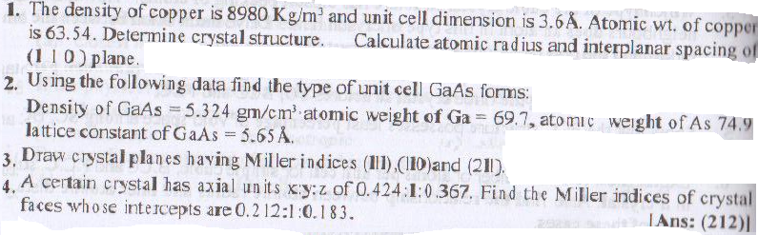
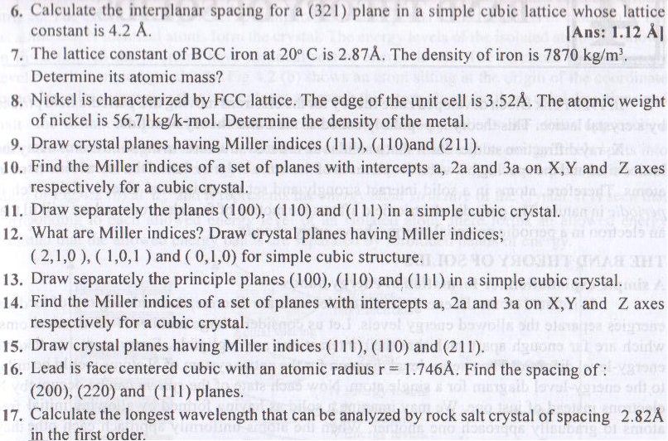
Ch-4 BAND THEORY OF SOLIDS
