Government Engineering College, Bhuj
Semester-1 [Electrical,Mechanical,Civil]
Assignment-1 Engineering Physics

Ch-1 Architectural Acoustic
- Explain: Reverberation and Reverberation time.
- Write the difference between Sound Intensity and Loudness.
- Write short note on Coefficient of Absorption and explain its Unit.
- Write Sabine’s Formula for reverberation time and explain the terms used in it and what are the limitations of Sabine’s Formula.
- Explain how the reverberation time of a hall is affected by
(a) Size (b) Nature of its wall (c) Audience
- List the factors affecting the Reverberation time of auditorium and explain.
Ch-2 Ultrasonics
- Explain Magnetostriction Method for Production of Ultrasonic sound.
- Explain Piezoelectric Method for Production of Ultrasonic sound.
- How can be Ultrasonic waves Velocity determined using Acoustic diffraction method? Explain.
- List the applications of Ultrasonic sound and explain any two.
Ch-8 Super Conducting Materials
- Explain the phenomena of Superconductivity.
- What is the physical significance of critical temperature, critical magnetic field and critical current density in superconductor?
- What is relation between critical temperature and critical magnetic field? explain.
- Explain the properties of superconductivity:
Isotope effect, Entropy, Heat Capacity, Persistent current, Flux Quantization
- Write a short note:
Meissner Effect, London Penetration Depth, Type-1 and Type-II superconductors
- Explain BCS theory for superconductivity.
- Distinguish between Type-1 and Type-II superconductors.
- Explain ac and dc Josephson Effect.
- Write a short note on applications of superconductivity:
Magnetic Levitation, SQUID, Properties of High T_{c} superconductors.

Numerical
Ch-1 Architectural Acoustic
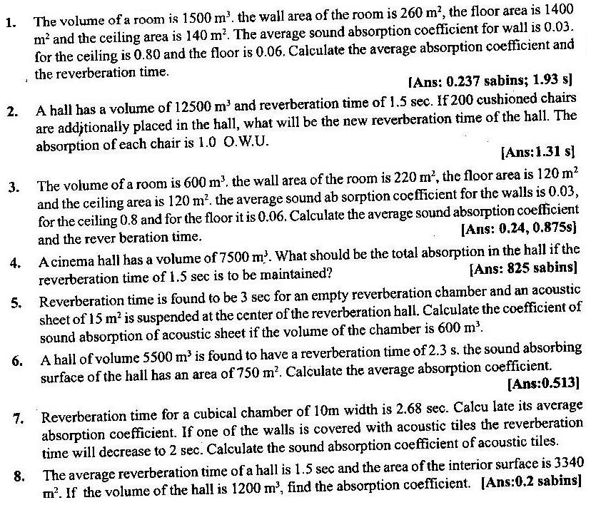
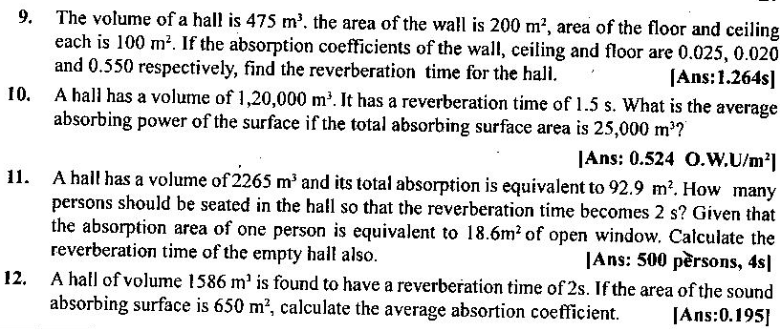

Ch-2 Ultrasonics
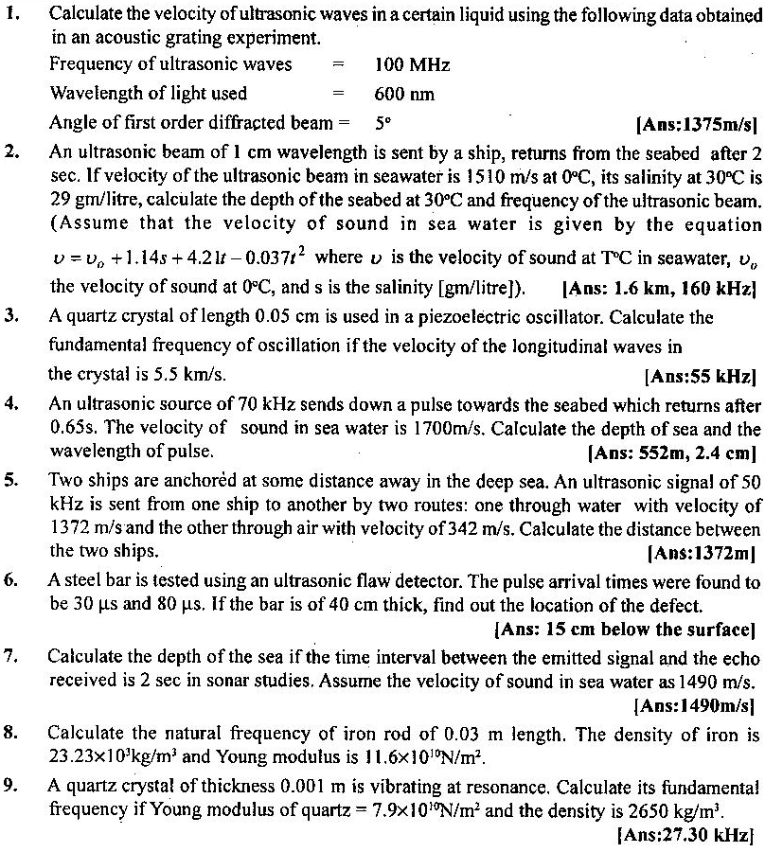

Ch-8 Super Conducting Materials
